CSS Declarations [Values]

Values

Values describe how the feature must be handled by the browser engine. Each property has their own appropriate values, having a formal grammar and sematic meaning, that can be executed by the browser engine.

**Value-processing**

The given value in a CSS property for a given element is the result of many steps being calculated.

Declared Values

Each declaration of property applied to an element gives a declared value for that property will be with the element. Then the values will be processed to choose a single “winning value” by the cascade.

*Cascade* sorts the unordered list of declared values by their declaration’s priority and outputs a single cascaded value.

Cascaded Values

This value represents the result of the cascade. The declared value that wins the cascade but if the output of the cascade is empty then there is no cascaded value.

Specified Values

The value of a property that the author purposely set for that element. The specified value is the cascaded value in some cases of the declarations. But if there is no cascaded value then the specified value is defaulted.

Inherited properties have their defaults from their parent element through inheritance and other properties take their initial value. It can be requested by the author through inherit and initial keywords.

Computed Values

This value is the result of having a solution to the specified value, generally making it absolute in preparation for inheritance. The computed value is transferred from parent to child during the inheritance.

Used Values

It is the result of getting the computed value and completing the remaining calculations to be absolute theoretical value used.

Actual Values

This is the used value after some adjustments have been made. The adjustments that user agent may not use of the used value in a given environment, like the font size may need some adjustment for the availability of fonts or the value for the property ‘font-size-adjust’.

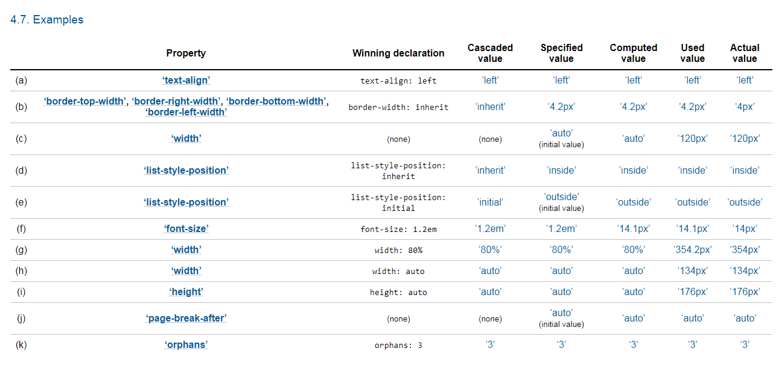

Reference: <https://www.w3.org/TR/css-cascade-4/#value-stages>

**Value Type**

Keywords

Keywords are value types which is a CSS identifier and some keywords are accepted in all CSS properties like the keywords *inherit*, *initial* and *unset*. Keywords appears literally, which it has no quotation marks.

Examples: auto, smaller or ease-in

Numbers or Numeric values

Dimensions

Refers to a number with a unit attached. It is use to specify the distance or length, duration or time, frequency, and resolution.

Length-Units

Two types: Relative and Absolute units

Relative units use for relating another length. It generates flexible output.

Examples:

em- relevant in font-size

ex- ‘x-height’ of fonts

rem- font size of root element

vw- viewport’s width

vh-viewport’s height

Absolute units are specified fixed width. It is useful when the length of output is known. Consist of the physical units (in, cm, mm, pt, pc) and visual angle unit (px).

Examples:

cm-centimeters

mm-milimeters

in-inches

pc-picas

pt-points

px-pixels

|  |  |  |  |  |  |  |  |
| --- | --- | --- | --- | --- | --- | --- | --- |
| Angle Units | | Duration Units | | Frequency Units | | Resolution Units | |
| deg | degree | s | seconds | hz | hertz | dpi | dots per inch |
| grad | gradians | ms | milliseconds | kHz | kilohertz | dpcm | dots per centimeter |
| rad | radians |  |  |  |  | dppx | dots per px unit |
| turn | turn |  |  |  |  |  |  |

Other quantities

Percent

A value having a number with percent sign, indicating the value which is some fraction of other value. Percentage can be applied in different data type like length-percentage represents a fraction of a length value.

Examples: width: 50%; line-height: 200%; voise-pitch:25%;

URLs and URIs

Resource locators having a syntax of *url(“http://www.google.com/singing.gif”);* -it can be also written without quotation marks.

**Colors**

Used to define a color value having two formats.

Keyword or the name of the color and numbers with some color notations like #rgb rgb() -combination of red green blue, rgba()- red, green, blue with opacity, hsl ()- hue, saturation and lightness and hsla()- hue, saturation, lightness with opacity.

Examples: color: black; color: #000; color: rgb(0,0,0), color: rgba(0,0,0,1); color: hsl(0,0%,0%); color: hsla(0,0%,0%, 1);

**Strings**

Having a sequence of characters used to some CSS properties like content, font-family, and label. It can be surrounded by double quotes or single quotes. Most characters can be represented with their respective Unicode code points example \22 represents a double quote (“ ”).

Examples: font-family: "Arial Black", Gadget, sans-serif; content: \2193;